Thomas Thornton Powell (Australian soldier)
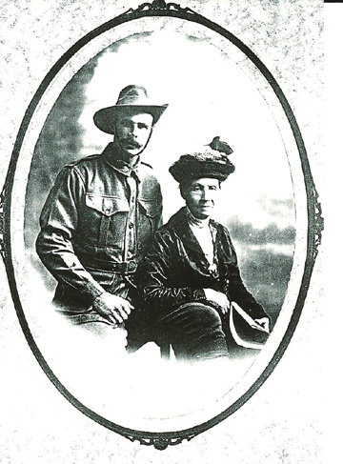
Thomas Thornton Powell was the fourth son and sixth child of Charles Henry Powell and Helena Louisa (nee Barney) and was known to the family as Thornton. His mother, Helena Louisa Powell, was born in Jamestown on St Helena, just off the coast of Africa. Her father was Captain John Edward Barney (1801 – 1855). He was promoted to Captain in 1842 and stationed at St Helena (hence her name).
- Thomas Thornton was born in Fortitude Valley, Brisbane, Queensland on the 14th September 1879. He had hazel eyes, black hair and a dark complexion (info from Service records)
- His father died at a young age
- Thomas Thornton never married and hence has no direct descendants
- He went to work as a Timber Cutter for the mills in Maryborough, and also worked as a ‘Timber Getter’
- His home was at Traveston Station, south of Gympie, where he bought 116 acres of the Traveston Station and farmed cattle
- He was also a Widgee-shire Chairman from 1913 to 1914 and Shire Councillor 1910 to 1915
- He volunteered to fight for the Commonwealth and Mother Country England in 1915
- After initial training he embarked on HMAT A16 ‘Star of Victoria’ on March 31st 1916 from Sydney
- Private Powell joined the 15th Reinforcements and, a month after leaving Sydney, arrived at Tel-el-Kebir, Egypt”
- “Here he joined D Company, 47th Battalion, AIF – a unit raised three months earlier which included Gallipoli veterans and new recruits
- Thomas found himself shipped to Marseille, in southern France. Just a few weeks later, he was fighting in the First Battle of the Somme

The HMAT A16 Star of Victoria, later renamed Port Melbourne, weighed 9,152 tons with an average cruise speed of 13.5 knots or 25.00 km ph.  It was owned by the Commonwealth & Dominion Line Ltd London and leased by the Commonwealth until 2 October 1917. | 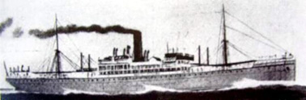

T T Powells family tell of him being wounded at Pozieres
The Battle of Pozieres  The Battle of Pozieres was a part of the Somme Battle which had been fought in northern France since July 1916. Australian troops were instructed to capture the town of Pozieres so that they could benefit from its vantage points.  While this was accomplished in a few days, it was the several weeks of heavy bombardment by the Germans which ensued that made this battle an absolute nightmare.  By August, after seven weeks of fighting, there were almost as many Australian casualties as had been suffered in the entire Gallipoli Campaign. | 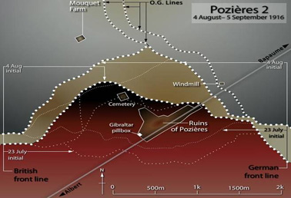

Following wounds in his leg and foot T T Powell would receive treatment at first aid post, he would then be moved to a field hospital before being sent by hospital ship to England.  Thomas was transferred after treatment in England to an auxiliary hospital at Hammerton House on September 20, 1916. Hammerton house was a former 1812-built manor house in Gray Road.  He died on 21st November 1916 just at the point of being repatriated home to Australia.  His widowed mother later received his personal effects which included a belt, devotional book, knife, brush and comb, pencils, badge, identity disc, matchbox, cigarette lighter and his photographs, letters and wallet. It would be two more years, however, before a photograph of his grave and final resting place was finally presented to his family. Mrs Powell died in 1921. | 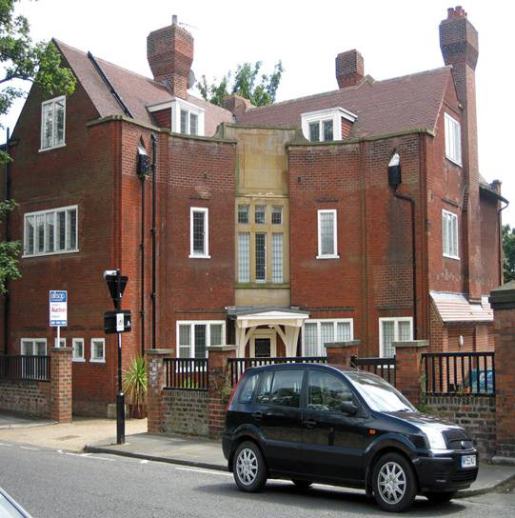

In 1923 that Thomas’s brother H.J. Powell, an Australian customs officer, received an official tribute to his bravery. “He was given a small bronze medallion, displaying an image of Britannia and the words ‘He died for freedom and honour’. (see below)
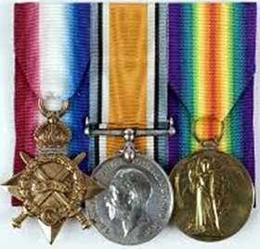 | 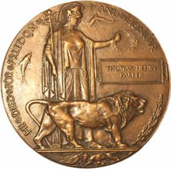 | 